# How To Create a Pull Request on GitHub

### **Fork the Repository**

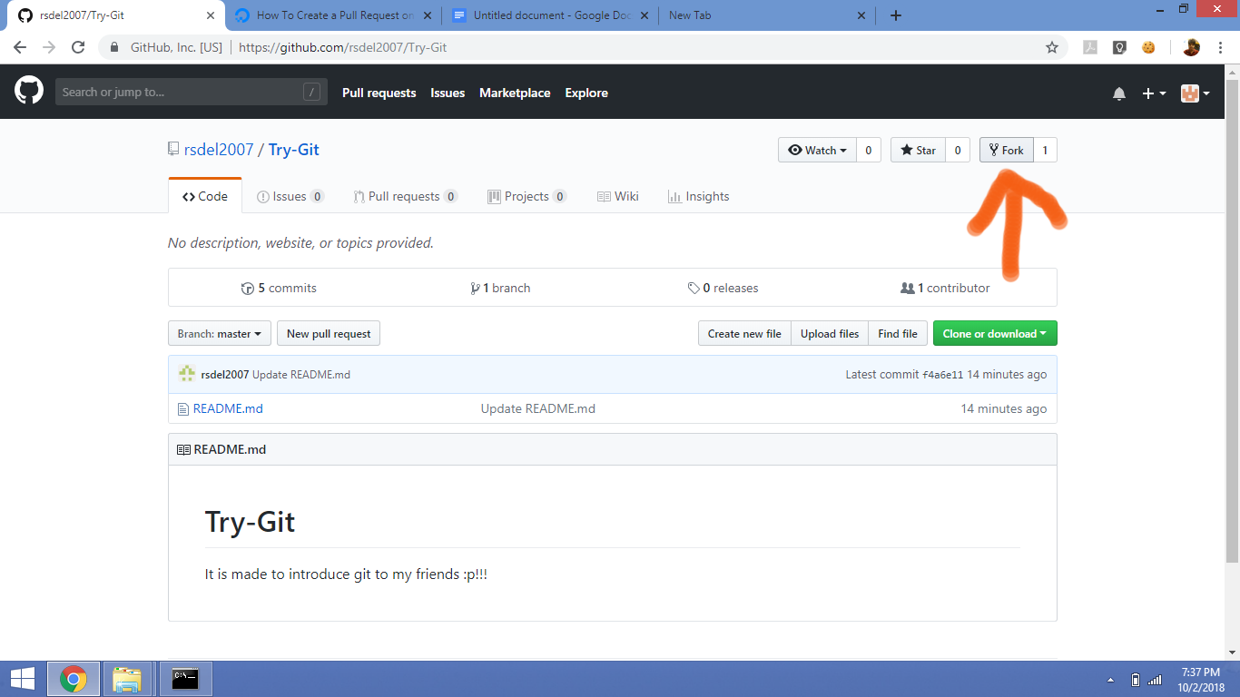

Click on the fork button to start the forking process. Within your browser window, you’ll receive feedback that looks like above.

Once the process is done, your browser will go to a screen similar to the repository image above, except that at the top you will see your username before the repository name, and in the URL it will also say your username before the repository name.

So, in the example above, instead of rsdel2007 / netbox at the top of the page, you’ll see your-username / netbox, and the new URL will look like this:

https://github.com/your-username/netbox

With the repository forked, you’re ready to clone it so that you have a local working copy of the code base.